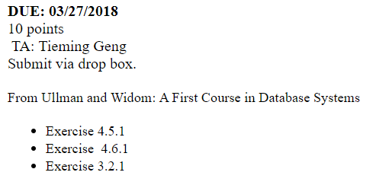



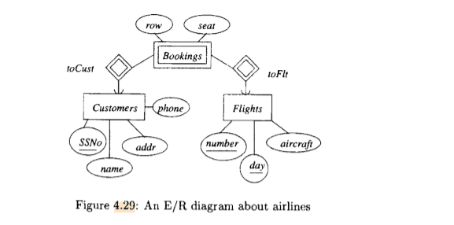

Bookings ( CustomerSSNo, FlightNumber, FlightDay, row, seat )  
Customers ( SSNo, name, addr, phone )  
Flights ( number , day, aircraft )

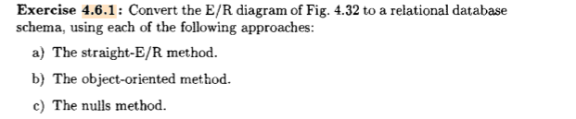

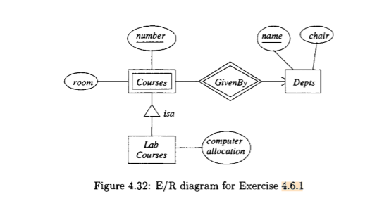

1. **The straight E/R method**

Courses ( DeptName, number, room )  
Depts ( name, chair )  
LabCourses ( DeptName, number, computer allocation )

1. **The object oriented method**  
   Courses ( DeptName, number, room )  
   Depts ( name, chair )  
   LabCourses (DeptName, number, room, computer allocation )
2. **The nulls method**  
   Courses ( DeptName, number, room, computer allocation )  
   Depts ( name, chair )

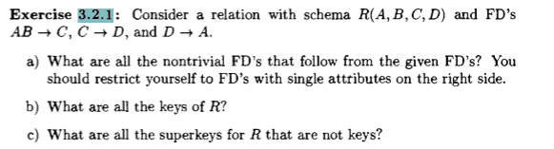

a)  
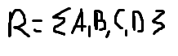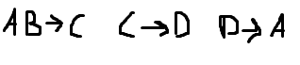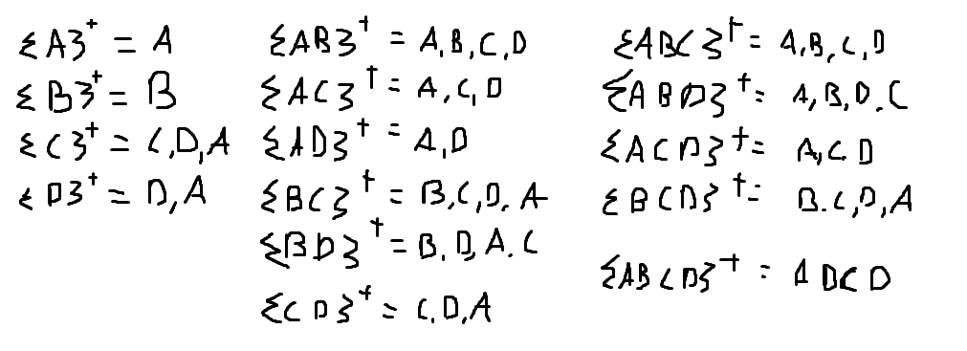

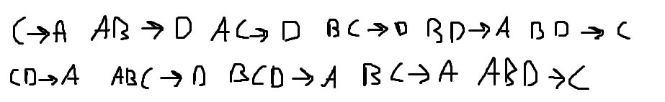

b) the keys are: {AB}, {BC}, {BD}

c) the super keys are: {ABC}, {ABD}, {BCD}, {ABCD}